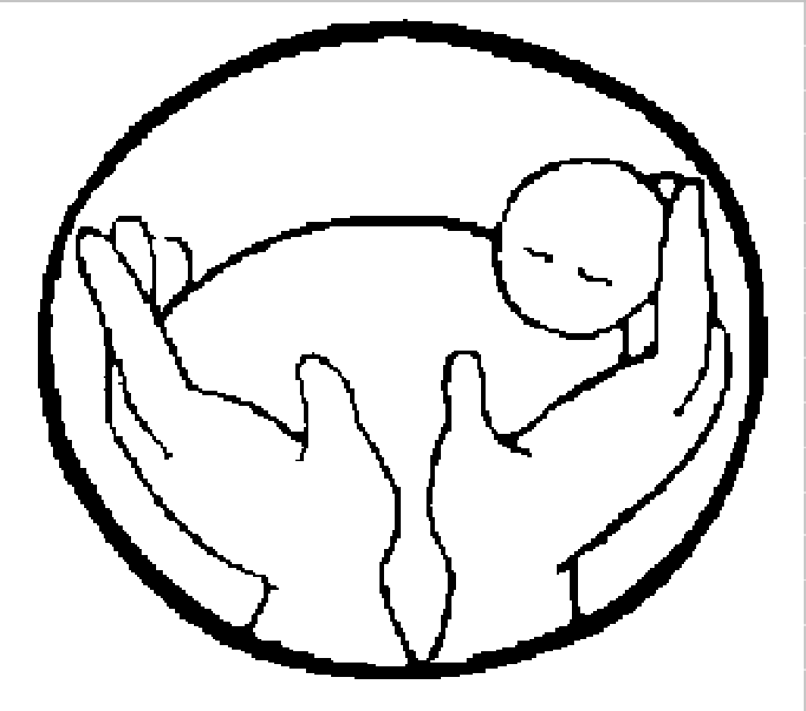

THE NAOMI PROJECT

A Program of Britepaths

Volunteer Application Form

This form has been made so that it can be filled using your Microsoft Word. Please feel free to type right into the document.

Date:

- Personal Information

Name Date of Birth Sex

Address

City State Zip

Phone E-mail address

Emergency Contact

Phone

- Education and Training

Educational Background ☐ Highschool ☐ College ☐ College Grad

Additional Training
Are you conversational in a foreign language? ☐ Yes ☐ No If so, which language?

- Experience
Name of Employer:
Describe any work experience that might be applicable to Naomi mentoring:

4. Drivers License? Yes☐No ☐
Has your license ever been revoked? Yes ☐ No ☐
Have you ever been convicted of DUI? Yes ☐No ☐
Name of auto insurance company

5. Do you have any chronic or recurring health problems that we should consider when making a match with a potential client? (Explain)

- Hobbies or special interests

- Approximate number of hours each month you feel you can devote to this volunteer program: Length of Service:

- Would you be able, if needed, to attend a Childbirth Preparation Class with a client and then be her childbirth coach? Yes☐ No ☐

9. Where did you learn about the Naomi Project?

- References: Please do not use a relative.

Name Title/relationship

Address

Phone

Name Title/relationship

Address

Phone

In completing this application for becoming a volunteer, I understand that I am not an agent or employee of Britepaths or the Naomi Project, and I further understand that this form is not and application for employment. I authorize release of information for Britepaths to obtain criminal and reference checks for the position(s) for which I am applying. I certify to the best of my ability that the information provided on this application is true and accurate. I also understand that misinformation knowingly provided here, and on subsequent volunteer information forms, is grounds for dismissal.

The Naomi Project would like to promote our programs and volunteering by using photographs of volunteers in action. Check here ☐ if you do not wish for your photograph to be distributed in Britepaths or Naomi Project publications.

Date Signature
Please return the completed form and a check for $35 made out to the Naomi Project
to cover registration costs, study materials, and lunch.
The Naomi Project, a Program of Britepaths
4080 Chain Bridge Road, Fairfax, VA 22030
naomiproject@hotmail.com

